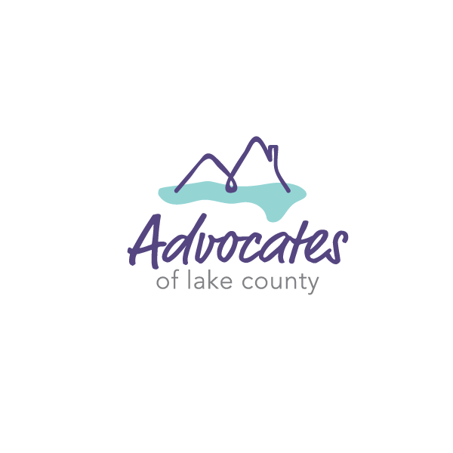
Diversity Services Coordinator Job Description

Job Summary: The Diversity Services Coordinator is a direct service and outreach position. The Diversity Services Coordinator develops and strengthens culturally engaging outreach for Latinx survivors, youth survivors and survivors identifying as LGBTQ+. In addition, they provide support, advocacy, options, and referrals to victims of domestic violence, sexual assault, stalking and other violent crimes. The Diversity Services Coordinator is responsible for staffing the agency 24-hour crisis line on a rotating basis and is supervised by the Advocacy Manager. This position requires a commitment to assisting victims, the ability to establish and maintain professional boundaries, strong communication skills, and the acceptance of social and cultural diversity.

Direct Client Services- 75%
- Provide crisis intervention, follow-up, support, advocacy, information, and referrals to victims both in-person and over the phone (through the 24-hour crisis hotline).
- Cover the 24-hour crisis line on a rotating basis and respond on-scene to provide emergency services to victims of crime.
- Conduct check-ins with clients and provide necessary follow-up advocacy.
- Assess victim safety and assist with safety planning including the arrangement of shelter, hotel/motel accommodations or other housing options as needed.
- Provide advocacy on behalf of clients working with community-based systems such as law enforcement, courts, social services, mental health providers, substance abuse services, etc.
- Accompany clients to appointments and meetings to secure financial assistance, explore long-term housing options, arrange for childcare, and obtain legal assistance.
- Provide legal advocacy including assistance with protection orders, victim’s compensation, divorce filings, child support and criminal/civil court support.
- Identify resources within the community and maintain good working relationships with community programs offering assistance to clients.
- Immediately report suspected child abuse and neglect to the Advocacy Manager or Executive Director.
- Collaborate with Housing Advocate and Housing Coordinator when a Latinx survivor, youth survivor or survivor identifying as LGBTQ+ is housing insecure.
- Facilitate ALC’s support group in Spanish (in conjunction with the Housing Coordinator as they facilitate the support group for English-speakers).

Indirect Client Services
- Maintain client records. Compile client data and information and complete program reports.
- Develop and maintain good working relationships with key local and statewide contacts.
- Maintain professional and effective working relationships with other organizations, community leaders, and ALC’s board, staff, and volunteers.
- Foster an inclusive safehouse and office environment in which all clients are treated equally, regardless of race, ethnicity, national origin, disability, sex, sexual orientation, gender expression, gender identity or religion.

- Perform other related duties as assigned.

Outreach Services-25%
- Recruit Promotoras from local Latinx communities.
- Coach Promotoras throughout the program by meeting individually bi-weekly.
- Develop a strong group dynamic by meeting in a group weekly or bi-weekly.
- Provide intervention services and educational curriculum that is culturally and linguistically relevant around domestic violence, sexual assault, teen dating violence and stalking to the Latinx community in Lake County.
- Provide specialized intervention services and educational curriculum for Lake County’s LGBTQ+ community and youth population.

Minimum Requirements:
- Understanding of issues facing victims of domestic violence, sexual assault, and other violent crimes.
- Demonstrated ability to apply problem solving and critical thinking skills.
- Commitment to providing client-centered, empowerment-based services to victims of crime.
- Bi-lingual (Spanish-speaking) and bi-cultural (Hispanic culture) required.
- High school diploma or equivalent (G.E.D.)
- Able to pass background check
- Valid driver’s license, reliable transportation, proof of insurance and clean driving record
- Applicant must be able to respond to Lake County within 45 minutes of dispatch to fulfill on-call responsibilities

Desired Qualifications:
- Bachelor’s or Associate’s degree from an accredited college
- 1-3 years experience working with at-risk clients and related programs

Some evening, weekend, and overnight work will be involved
Full-time, benefited, non-exempt professional position
This job description is subject to periodic review by the Board of Directors
ALC is an Equal Opportunity/Affirmative Action Employer

To apply, please send resume and cover letter to: perla@advocatesoflakecounty.org.

